**National Park Portal**

**User Guide**

|  |  |  |
| --- | --- | --- |
| Supervisor |  | |
| Batch |  | |
| Group |  | |
| S: No | Enrolment No | Student Name |
|  |  |  |
|  |  |  |
|  |  |  |
|  |  |  |
|  |  |  |

Home Page = index.html

Image Hero Section

Logo/National Parks Info Home About Parks Animals Birds Sitemap Contact

Fig 1. Welcome Page with The Navbar & Attractive Image Of Nature With Animals Indicates The Wildlife National Parks

When The Site Opens The Welcoming Image & navbar To Attract More To Explore The Website To Get The Information From The National Parks Info Website

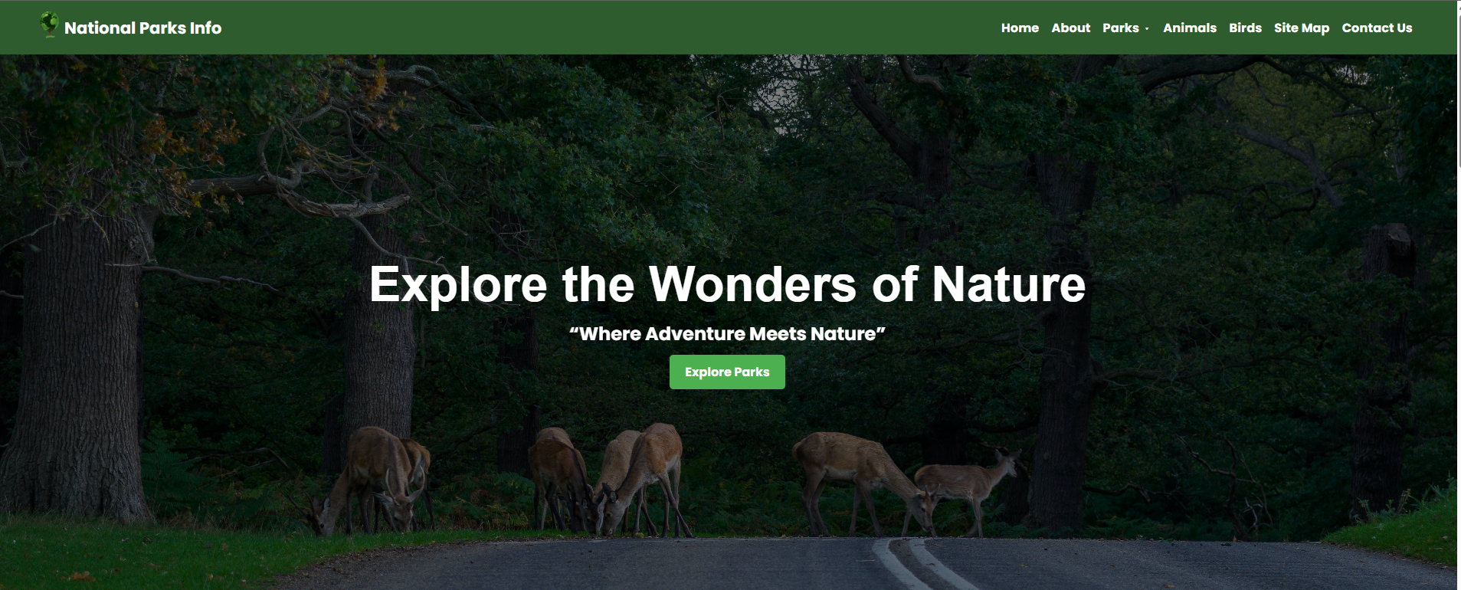

This Is The Welcoming Website Attraction To Explore More Information About The Nature & wildlife .

Fig 2: Home Page Frame Interface

About Page = about.html

The User Guide For the About Page Simply Click On The About In Navbar Then Page Of About Will Open.

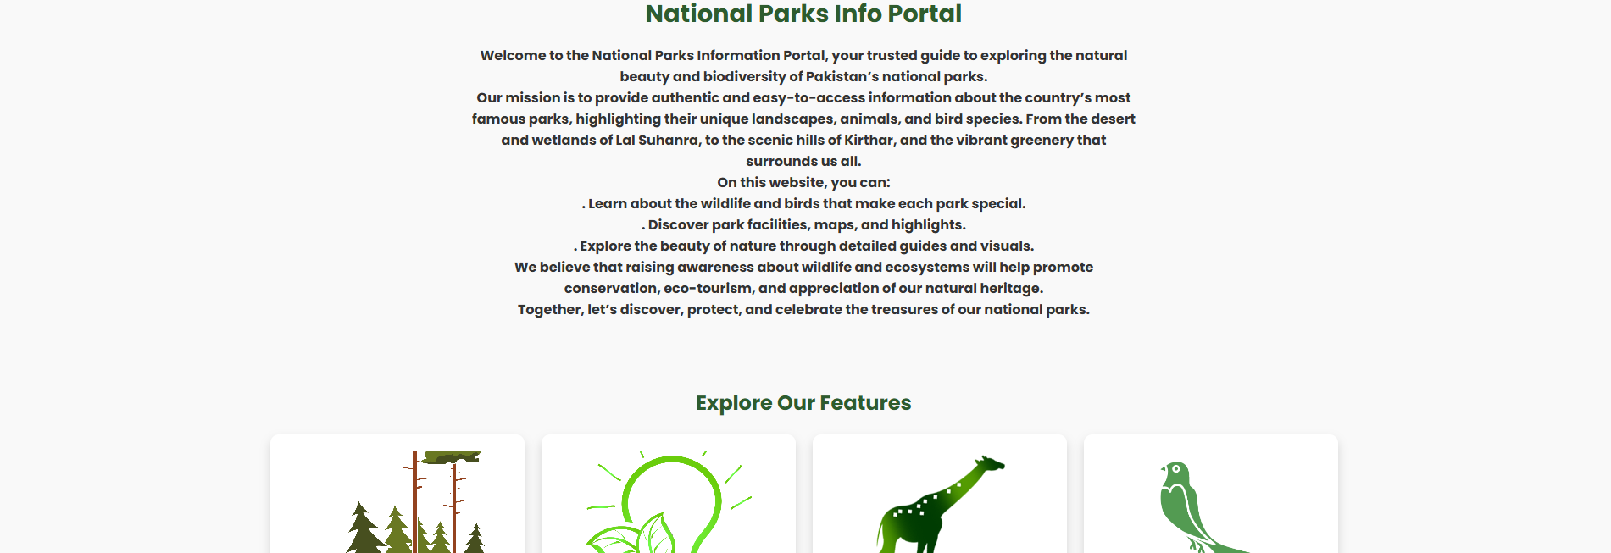

The Home Page Section In Which We Can Directly Explore The From Cards 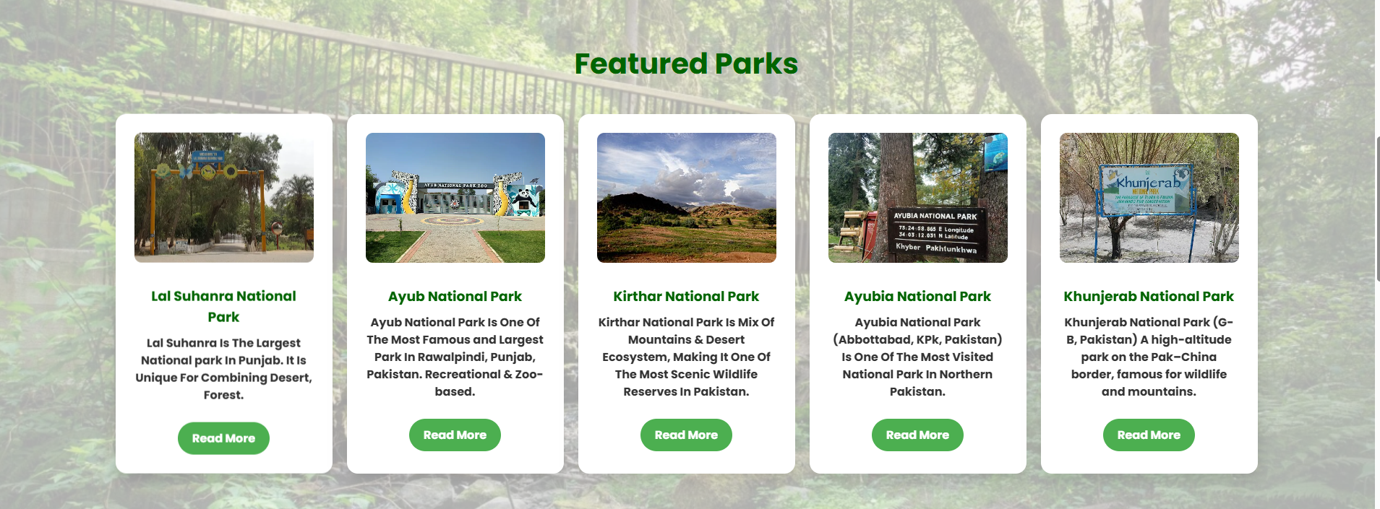

Explore The Parks From Here & Get Information About The Parks Its Location , Facilities , Animals , Birds & History Of Park

Navbar Guide:

1. Navbar Setting & Guide: Navbar You Can See In The Website With Asthetic Logo & Name National Parks Info You Can Click On The Logo To Come Again On The Home Page Section
2. The Pages On Navbar Indicates The Path Of The Relevant Pages Like About , Parks , Animals , Birds , Sitemap , Contact
3. Parks: When The click On The Parks The Dropdown Menu Come Out To Explore More Parks Like Lal Suhanra , Ayub , Ayubia , kirthar , Khunjerab



The DropDown Menu of Parks Will Be Click On The Parks Page Then It Will Be Dropdown

Logo/National Parks Info Home About Parks Animals Birds Sitemap Conta

Lal Suhanra Park

Ayub National Park

Kirthar National Park

Ayubia National park

Khunjerab National Park

Park Page = lalsuhanra.html

The Benefit Of This Website Is That It Has Download Option For Information To Get Easily Read Offline In Which The Park Location, facilities , Birds , Animals , Location & Many More

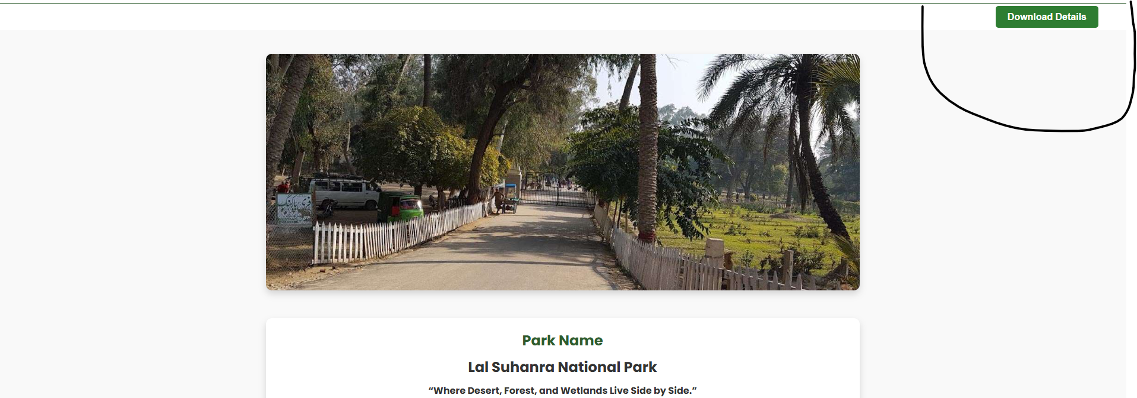

Given Mark Is Indicates To Download the Information of Park after Coming From The Park Page

Logo/National parks Info Home About Parks Animals Birds Sitemap

Lal Suhnara Park

Lal Suhanra Park Page

Animals Page = animals.html

The Animal Page In Which The Option Of The Relavent Parks Animals To Explore Them & Get Information

Logo/National park Info Home About Parks Animals

Lal Suhanra Park Animals

Lal Suhanra Park Animals

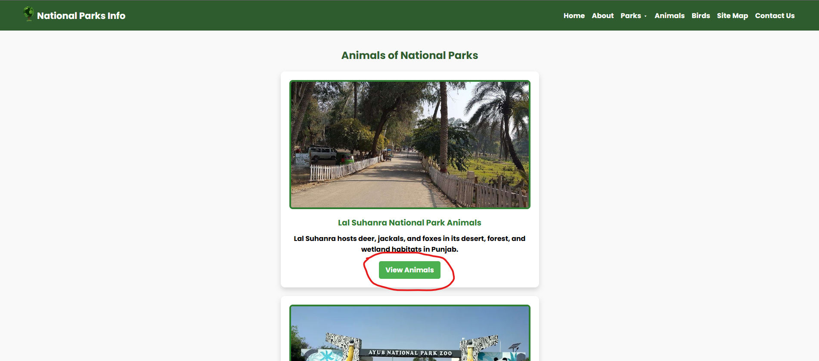

Birds Page = birds.html

The Birds Page Showing the Birds of The Relavent Parks To Get Information From This.

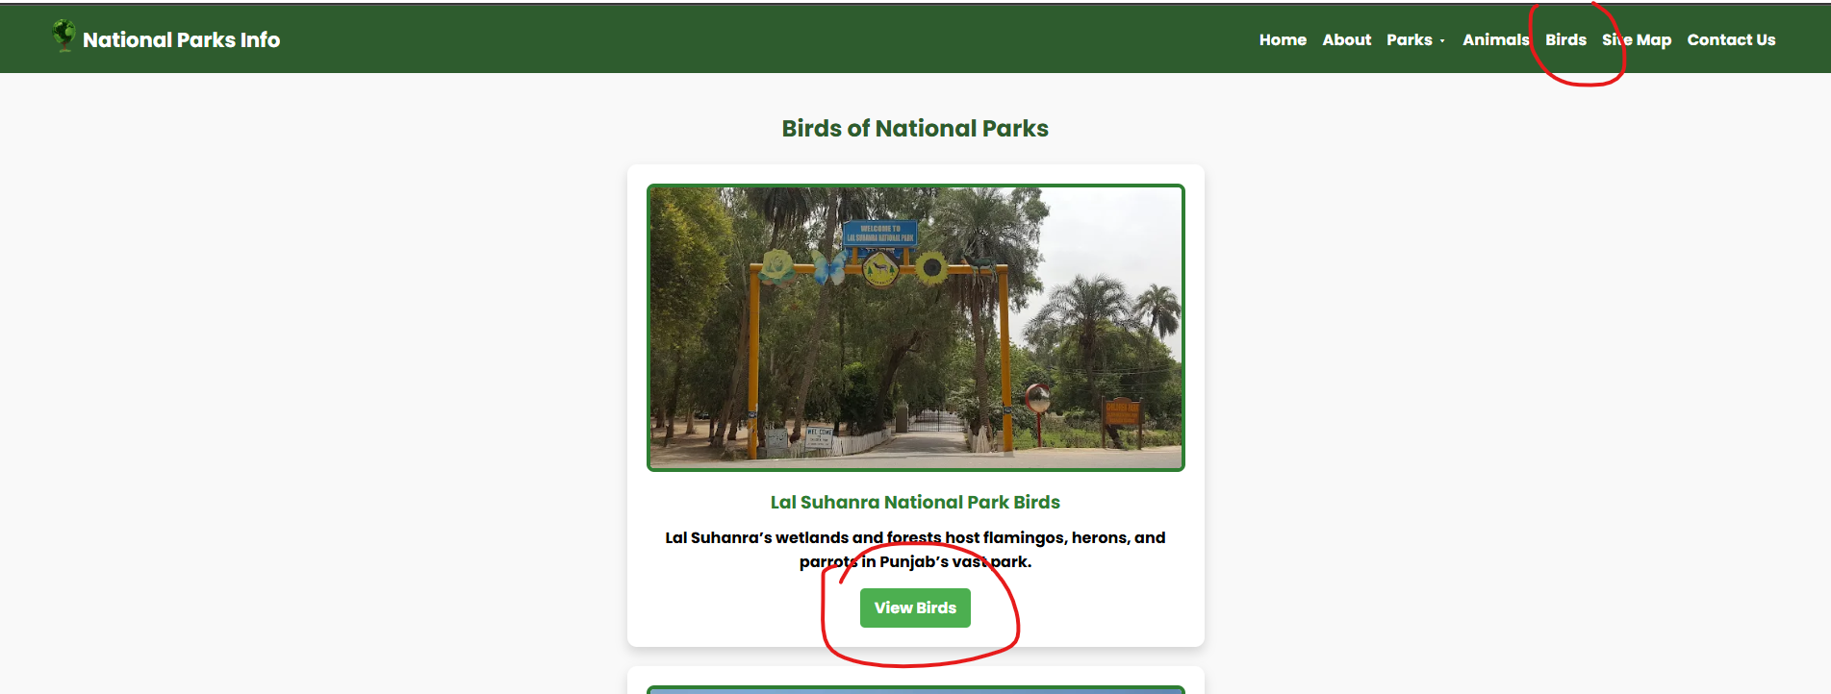

Home About Parks Animals Birds

Lal Suhanra Birds

Lal Suhanra Birds

Lal Suhanra Animals = lalsuhanra.html

The Animals Of The Park As You Can See This If You Click On The View Animals On The Animals Page Means Lal Suhanra Animal

You Clicked on It So It’s Opened The Animals Of The lalSuhanra Park Animals

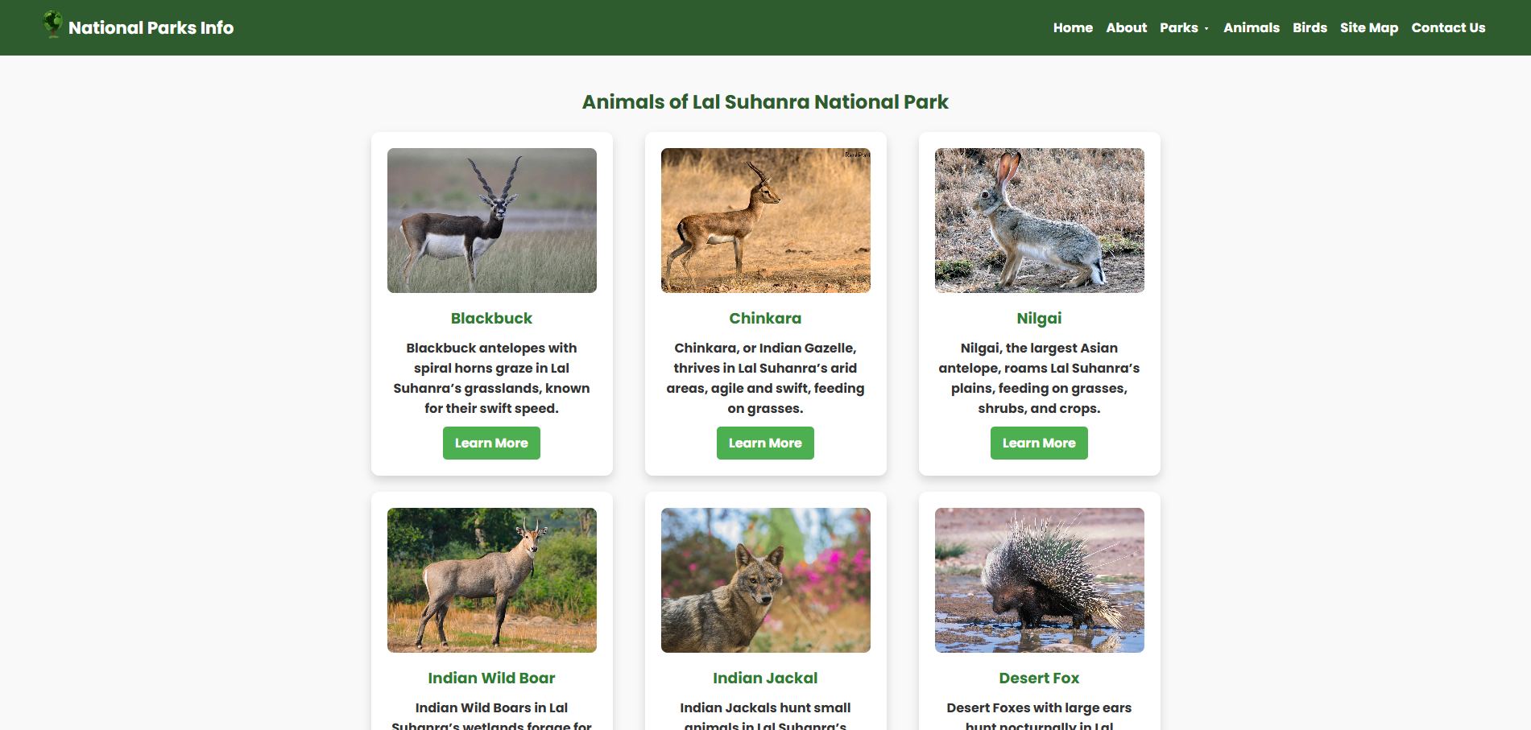

View Animals

View Animals

Lal Suhanra

Park

Animals of Lal Suhanra

Leapord

Chinkara

Wild Boar

Fox

LalSuhanra Birds = lalsuhanrabirds.html

The Birds of Lal Suhanra Park for Example If You Want To See & Get Information about The Birds

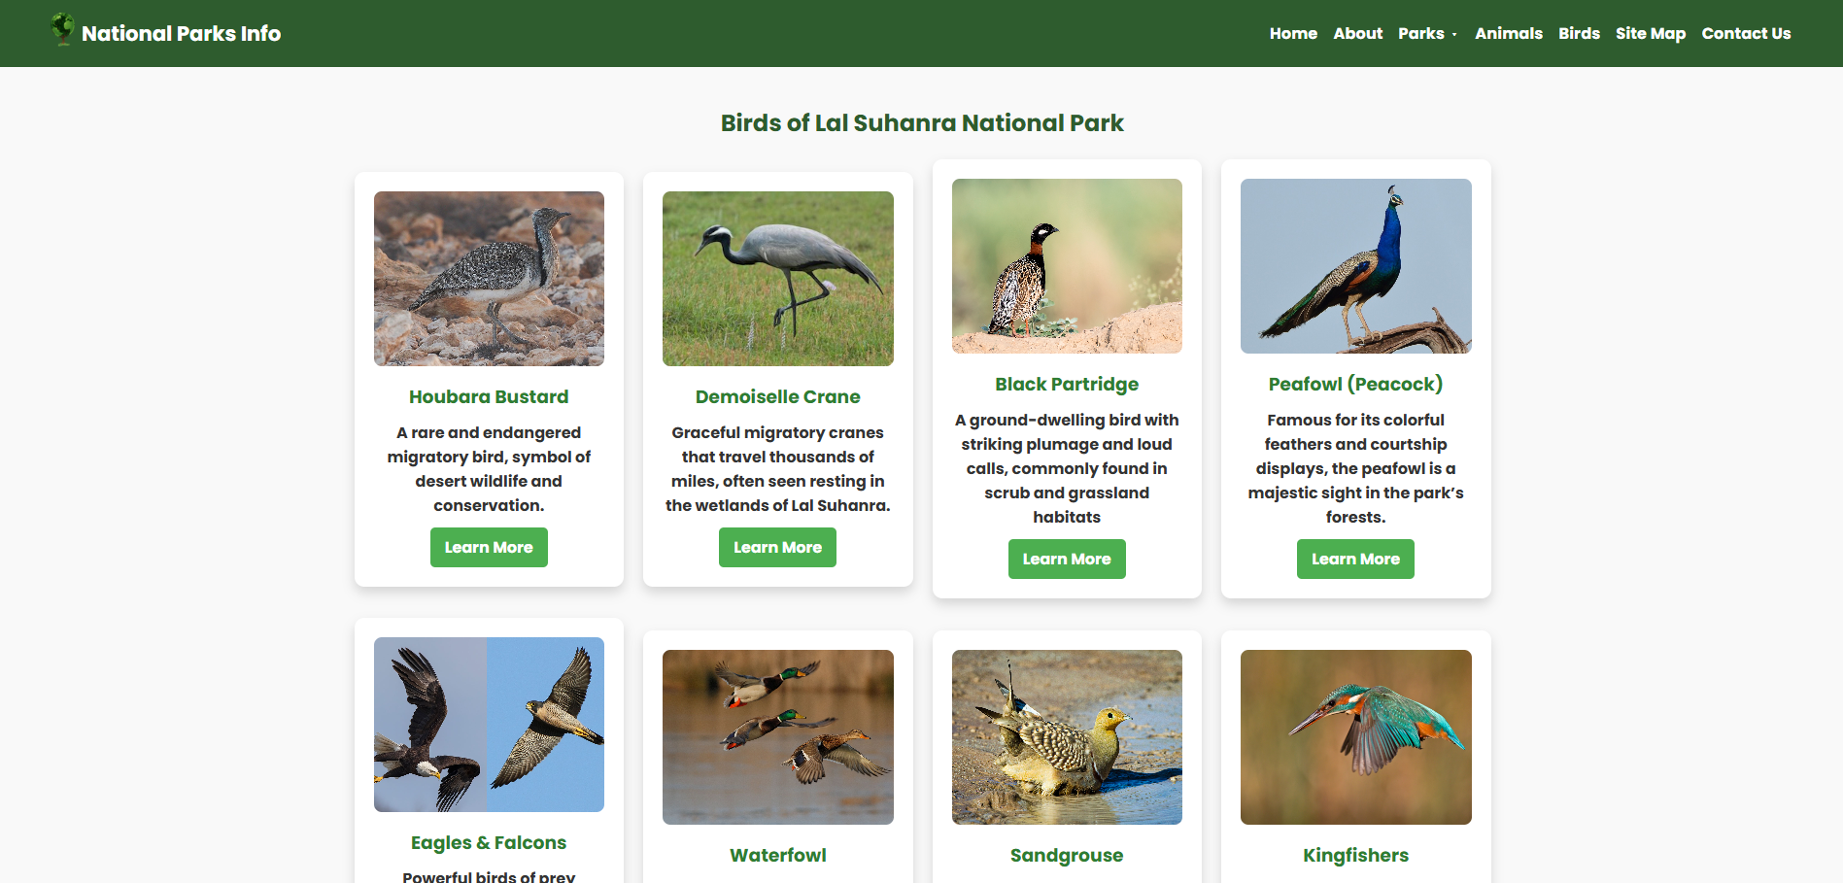

View Birds

Lal Suhanra Birds

Eagle

Ducks

Piegon

Falcon

Sitemap Page = sitemap.html

The Sitemap Usually For the Parks Location Using the Geo Location For Parks & Also Used For Direct Links Of Buttons In Website Of The National Park Portal.

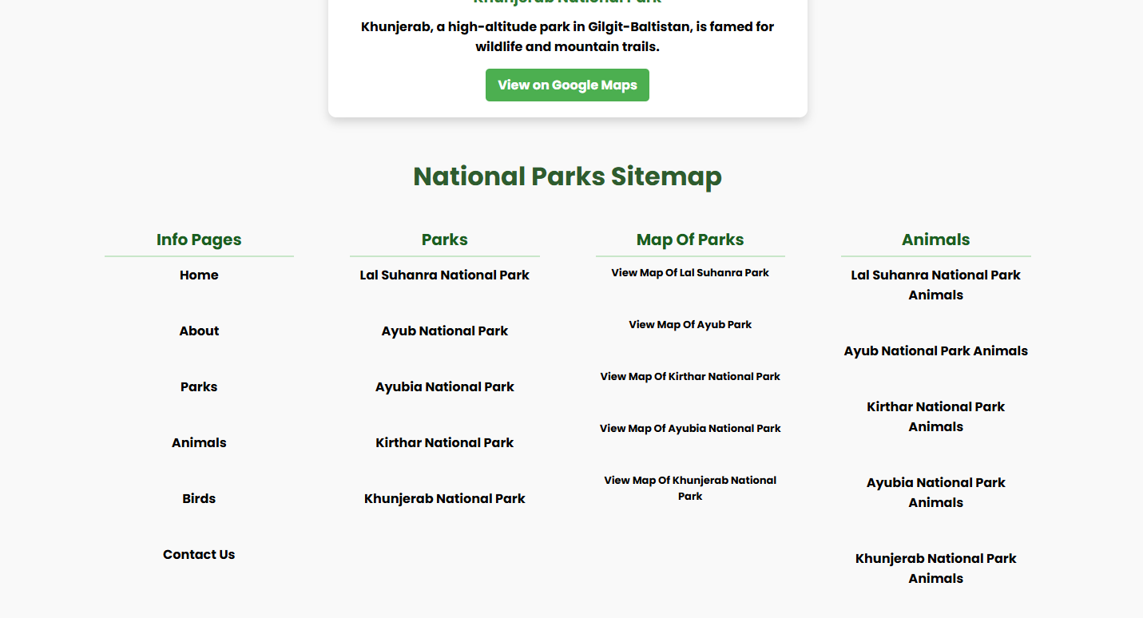

Logo/National Parks Info Home About Animals Birds Sitemap Contact

Quick Links For The Pages

Lal Suhanra Park

View Map

Contact Page = contact.html

The Contact Page Is Usually For The Visitors To Contact To The Parks Management To Get Information & Other The Contact Form Is Also Available For Visitors For Feed Back , Information and much more

View The Contact Information For Every Park

Contact Form

Lal Suhanra Park

Contact Info

**Thank You For Reading The Documentation. Please Follow The Instructions Above!!**